**SQL Database - Scale up your SQL DB size on Azure**

**Prerequisites**

* Azure account.

Now, let's get started with the steps, given below-  
  
**Step 1-**Sign in to the online [Microsoft Azure Portal](https://portal.azure.com/).  
  
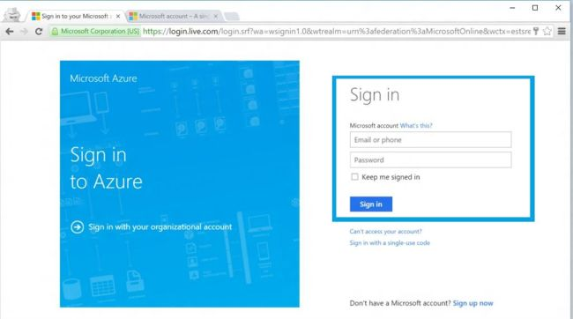  
  
On the SQL Servers blade, navigate to the monitoring blade of SQL database.   
  
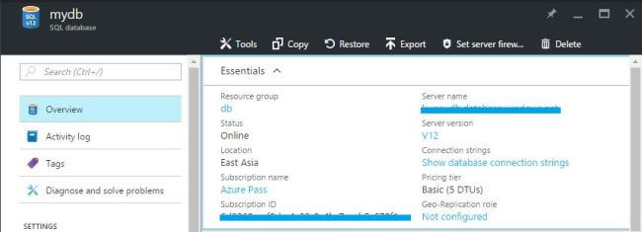  
  
Click Database Size option, which will display the monitoring settings.  
  
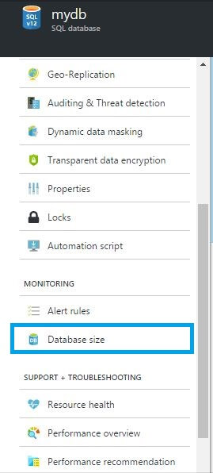  
  
Click Here button needs to be clicked.  
  
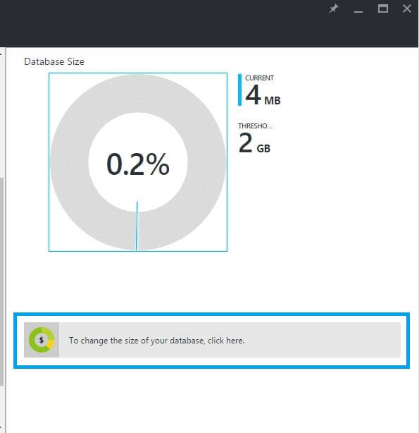  
  
Finally, we change the database size in the Service tier.  
  
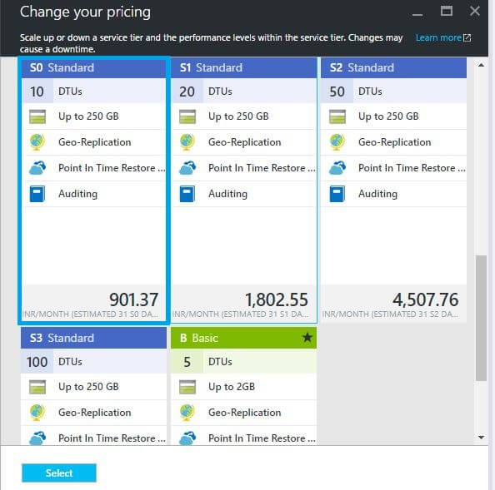  
  
We will receive the notification and our database size will be changed.